CS 312: Artificial Intelligence Laboratory

Lab 2 report

Ashwin Waghmare(210010060)

Tejal Ladage(210010026)

**• Introduction:**

The objective of this task is to solve Block World Domain. Block World Domain has an initial state consisting 6 blocks arranged in 3 stacks and we can move only top blocks of the stacks. Blocks World is a planning problem where we know the goal state beforehand. We have to achieve a goal state after a particular arrangement of blocks by moving the block. Number of stacks allowed during any arrangement is always three.

**• Description:**

**1. State space:**

A state space is the set of all configurations that a given problem and its environment could achieve. Each configuration is called a state. Here the state space is all possible permutations of the given ‘n’ blocks on 3 stacks.

**2. Start state:**

Start state is the initial arrangement of blocks at the start of the game.

**3. Goal state**

Goal node is the arrangement which we want to achieve in order to complete the game. The start states and goal states will be given in the input file.

**Example:**

Start state = [[‘A’, ‘GROUND’], [‘B’, ‘GROUND’], [‘D’, ‘C’, ‘GROUND’]]

Goal state = [[‘GROUND’], [‘A’, ‘B’, ‘D’, ‘GROUND’], [‘C’, ‘GROUND’]] jb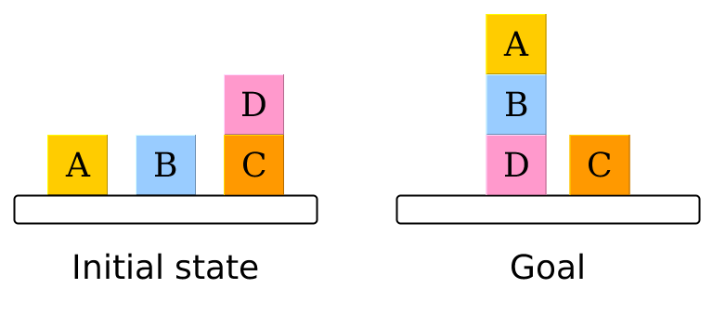

**• Pseudocode:**

1. **goalTest** :

function goalTest (currentstate):

if currentstate == goalstate:

Return True

else:

Return False

1. **MoveGen :**

function MoveGen (current_state):

initialise empty list for neighbours

if stack1:

tempcopy = copy(current_state)

pop element from stack1 and append it to stack2

append tempcopy to neighbours

tempcopy = copy(current_state)

pop element from stack1 and append it to stack3

append tempcopy to neighbours

if stack2:

tempcopy = copy(current_state)

pop element from stack2 and append it to stack1

append tempcopy to neighbours

tempcopy = copy(current_state)

pop element from stack2 and append it to stack3

append tempcopy to neighbours

if stack3:

tempcopy = copy(current_state)

pop element from stack3 and append it to stack2

append tempcopy to neighbours

tempcopy = copy(current_state)

pop element from stack3 and append it to stack1

append tempcopy to neighbours

**• Heuristic Functions:**

**A) Heuristic 1:** In heuristic1, we implemented following logic:

1) +1 for block if it is in correct stack and on the top of correct block. -1 for block otherwise.

Example:

Start state: [‘F’, ‘B’, ‘A’, ‘GROUND], [‘D’, ‘GROUND’], [‘E’, ‘C’, ‘GROUND’]

Goal state: [‘F’, ‘B’, ‘GROUND’], [‘A’, ‘C’, ‘GROUND’], [‘E’, ‘D’, ‘GROUND’]

Heuristicvalue of start state = -1-1+1-1-1-1 = -4

Heuristic of goal state = +6

**B) Heuristic 2:** In this heuristic function, we implemented following logiC.

1)+1 x (level of block) if block is in correct stack and on the top of correct structure i.e., all the block below it must be in correct form

2)-1 x (level of block) otherwise

Example: Start state: [‘F’, ‘B’, ‘A’, ‘GROUND], [‘D’, ‘GROUND’], [‘E’, ‘C’, ‘GROUND’]

Goal state: [‘F’, ‘B’, ‘GROUND’], [‘A’, ‘C’, ‘GROUND’], [‘E’, ‘D’, ‘GROUND’]

Heuristic of start state = -1-2-3-1-1-2 = -10

Heuristic of goal state = +9

**• Hillclimbing Table:**

startState = [['A', 'B', 'C','GROUND'], ['D','E' ,'GROUND'], ['F','GROUND']]

goalState = [['C','GROUND'], ['A','E', 'GROUND'], ['B','D','F','GROUND']]

|  |  |  |  |
| --- | --- | --- | --- |
| Heuristic function | States explored | Time Taken | Optimal Solution |
| Heuristic1 | 4 | 0.0049078 sec | Yes |
| Heuristic2 | 2 | 0.0024039 sec | No(Reaches local maxima) |

startState = [['A', 'B', 'C','GROUND'], ['GROUND'], ['D','GROUND']]

goalState = [['C','GROUND'], ['A', 'GROUND'], ['B','D','GROUND']]

|  |  |  |  |
| --- | --- | --- | --- |
| Heuristic function | States explored | Time Taken | Optimal Solution |
| Heuristic1 | 3 | 0.00428 sec | Yes |
| Heuristic2 | 3 | 0.00569 sec | Yes |